Piaget in C# for Dummies
This manual is an unofficial manual created to help the user who have never use RHY before.
This manual should help you understand some basic functions, features, and its capability of this robots including its codes.

Piaget Interface
The goal of Piaget interface is to gather in one place all the robots, sensors and robotic arms. The name of Piaget was chosen in honor of the Swiss psychologist Jean William Fritz Piaget, renowned for its work in developmental psychology. The interface is in the form of a large main window grouping various parts according to the different robots and sensors (see picture below). Over the years, the features available in Piaget increase. Most students who have completed a project to LaRA have implemented new functions for the various resources of the laboratory. Piaget is coded in C++.
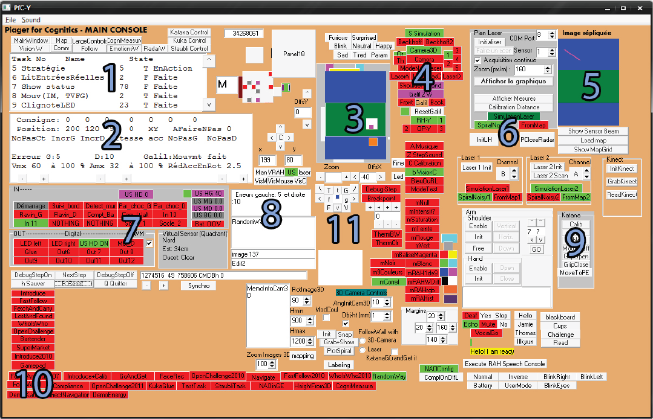
1. Current tasks.
2. Control panel of the servo, robot position and orders.
3. Representation of the environment, the robot motion.
4. Activation of sensors, simulation.
5. Control equipment.
6. Control panel-level laser sensors.
7. Status of the inputs / outputs can activate the outputs directly by pressing
on the corresponding icon.
8. Error display cards Galil.
9. Control panel and robot calibration Katana.
10. Buttons of different possible actions and panels.
11. Buttons robots OP-Y and Y-HR.
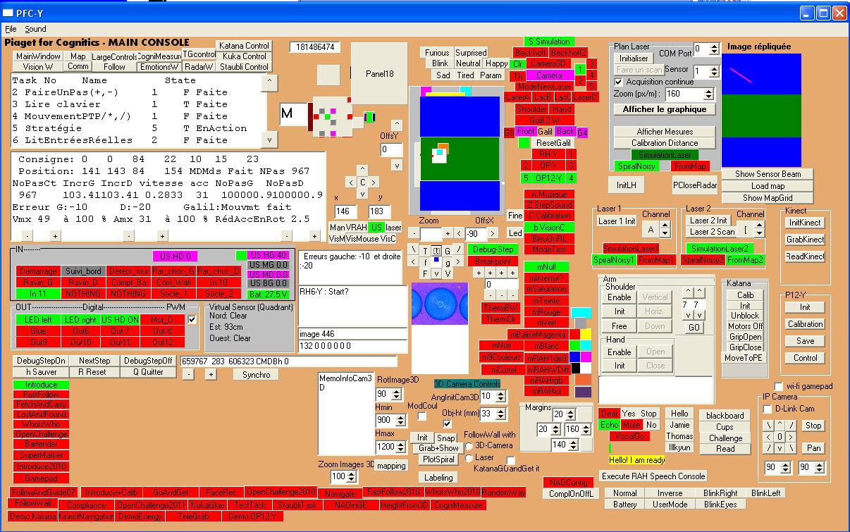
Picture from the C++ Piaget version
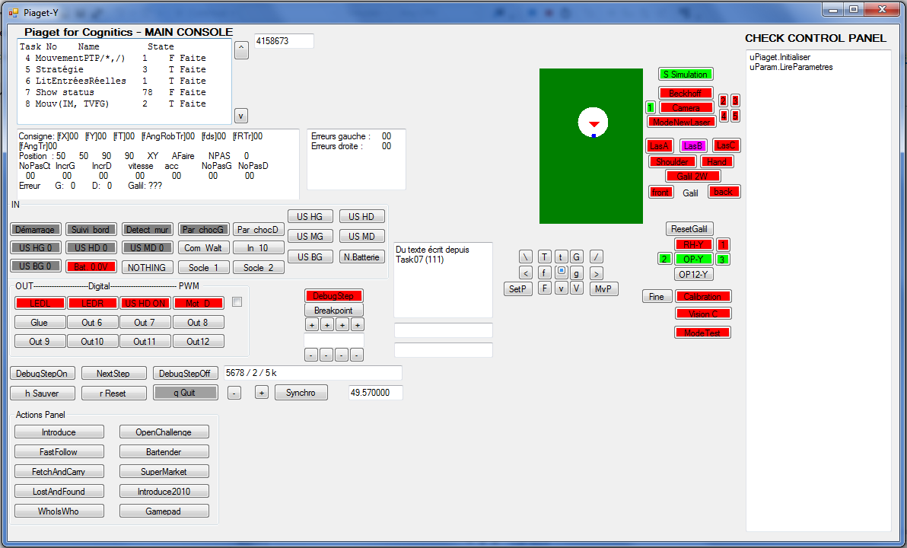
Picture from the C## Piaget version

***To begin***
After you run the program, you need to select the task for the robot to do. It's located on the Console right below "Saved," "Reset," and "Quit."
After the task is selected, you can give the Robot it Vocal Command "Go" and it will proceed as given.
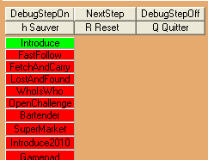

***Introduction***
Most of the Program are divided into tasks system where the program will go through these various tasks starting from task 1 to task 21 **require update if needed**
which are as follow:
,
Task02(); // Faire un pas - move a little bit
Task03(); // Lire clavier - read keyboard
Task04(); // Mouvements PTP - move point to point
Task05(); // Stratégie
Task06(); // Entrées / Sortie IO
Task07(); // Affichage - Display
Task08(); // Mouvements spatiaux - special movement for computing position of the robot
Task09(); // (* Gestion de la diode fonctionnement *) Led blinking
Task10(); // Analyse d'images
Task11(); // GestionServoCommandesUSB - usb motor controller no use
Task12(); // ajustement de la charge
Task13(); // Tester Entree -----------no use---------
Task14(); // Communication
Task15(); // Mesures plan laser
Task18(); // Interpréteur Piaget Multi tasking management
Task19(); // Voice dictation
Task20(); // Dialogue Manager
Task21(); // Map Manager

with the exclusion of task11 and task12 which are not in use anymore.
Most of the coding will be located in Task5 which is the most basic level of coding. Eventhough it's level1 coding, this task bear the most
effect on the robot's action and "Stratégie."

Task02 : move a little bit
Faire un pas - move a little bit

Task03 : read keyboard
Lire clavier - read keyboard

Task04 : move point to point
Mouvements PTP - move point to point

Task06 : Entrées / Sortie IO
Entrées / Sortie IO

Task07 : Affichage - Display
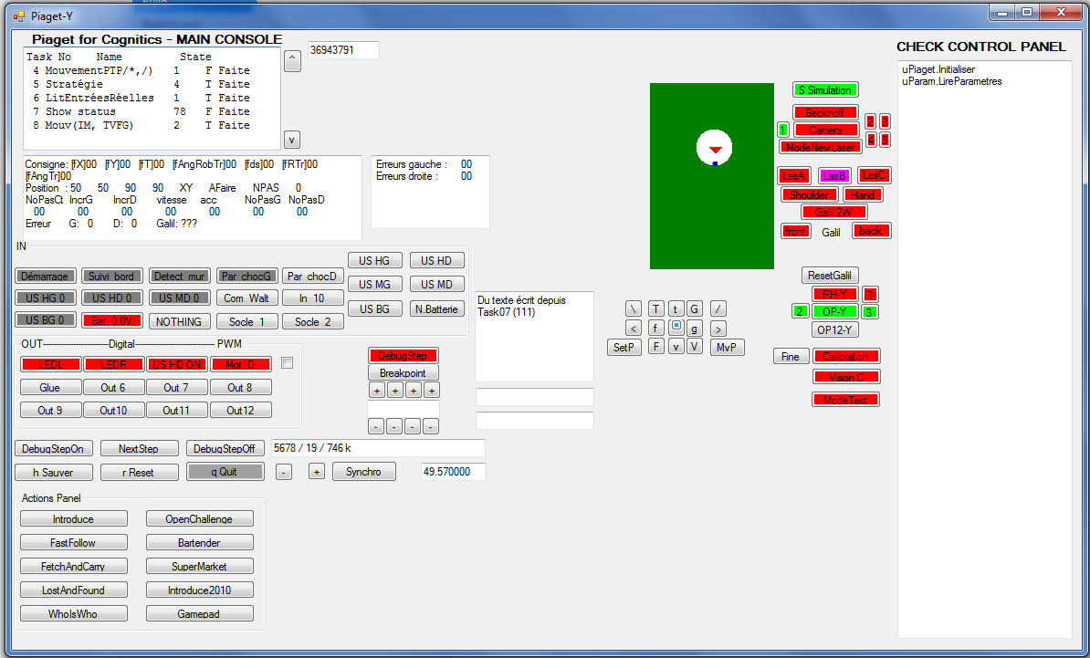
078 : this instruction handles the display of tBMemo1.
089 : this instruction handles the display of tBTicks.
this instruction handles the display of tBTicksPerSecond.
109 : this instruction handles the display of tBControl.
111 : this instruction handles the display of pTable. The white circle representes the robot. The blue circle representes the direction of the robot. The red triangle representes the path angle.
(see Task07. ClearPTable(System.Drawing.Graphics g))
(see Task07. DrawRobot(System.Drawing.Graphics g))
(see Task07. DrawDirectionRobot(System.Drawing.Graphics g, float cX, float cY,float ThRoDe))
(see Task07. DrawTriangleAngleRobotTraj(System.Drawing.Graphics g, float cX, float cY, float AnRoTr))
111 : this instruction handles the display of tBUser.
172 : this instruction handles the display of tBMouvement.

The zouzouPanel is the check board control Panel. It’s allow us to check the behaviour of the program, in which methode it’s passing through.
(for more information see uPiaget.WriteOnCheckBoard)
see Taks07.CorrectionAngle(float angleReal)

Task08 : Mouvements spatiaux
Like the main program, Task5 are divided into seperate "region" to perform different task base on what the goal the robot
need to meet before it finish. Here are some of the regions that we had used:

Case 4xx : deals with Navigation to set waypoint.
Case 15x and 4xxx : deals with Follow and Guide
Case 7xxx : deals with Who's Who

This is unofficial manual of the RHY Image processing process by Chayapol C.

***Form 2***
Most of the Image Processing process can be seen in the Form2, apart from Form1. However, anything shown on the monitor in Form2
can also be seen in Form1. It's very tiny but it's usable.
Notice in Form2 on the lower right hand corner there are different modes to choose from. I am here to explain
these modes.

***B VisionC***
This panel, once press will give the robot the continuous scan. When it's not press, the user need to press on the big Go button
in the center of the console to process the picture.

***Mode***
Image Processing of RHY consists of four mode as of the current version. these mode can be set in the Image
Form or set in the code using: /* ModeImage = mRAH1de9; */ or /* ModeImage = m9Couleurs; */ etc.

***m9Couleurs**
This mode will shows nine main color on the monitor.

****mRAHrgb****
This mode is calibrate to detect the orange color of the traffic jacket in the lab for testing purposes

****mRAHist****
This mode is unique in that this mode will detect the color that the user click on the picture. once the user click on that pixel and
press the "LearnColor" panel, the computer will detect all of the color on the monitor with the same color as the color that the user select.
Very useful and flexible mode but not necessary and overly complicated

****mRAH1de9***
This mode is similar to the m9Couleurs mode but you can select the color of the 9 color to detect.
These nine color can be specify by the variable: "RAHColor1de9" ranging from 0-8.

0=Red
1=Yellow
2=Lime
3=Aqua
4=Blue
5=Fuchsia
6=Black
7=White
8=MedGray

For example,
RAHColor1de9=6; //The computer will count all of the pixel that black in the image window.

***Image Processing Window***
Notice that the Robot does not detect all of the pixel on the monitor. To enlarge the image processing window, the user need to click on the
Ymin/max detect and Xmin/max detect panel to enlarge or shrink the processing window.

By coding, the programmer can use these as an example:
/*
XMinDetect=30;
XMaxDetect=60;
YMinDetect=3;
YMaxDetect=40;
*/

****Counting pixel***
Once the mode and the desire window setting are selected, The variable pix_count will count all of the pixel in the desire setting. this method have been tested for mRAH1de9, mRAHrgb, and mRAHist.

Task09 : Led blinking

Task10 : Analyse d'images

Task11 : GestionServoCommandesUSB

Task12 : ajustement de la charge

Task13 : Tester Entree

Task14 : Communication

Task15 : Plan laser

Task18 : Interpreter Piaget

Task19 : Voice dictation

Task20 : Dialogue Manager

Task21 : Map Manager

***Calibration***
To do the color calibration for distance detection. First stand about half a meter from a camera and press the Calibration50cm panel.
Then the user should stand about two meter from the camera and press the Calibration2m panel. This will help the Robot determine the distance of the object

This is an unofficial manual for Robot movement.

AvancerAGN(DISTANCE)
-Move forward DISTANCE cm

ReculerAGN(DISTANCE)
-Move backward DISTANCE cm

MoveToAngle(ALPHA)
-It will move to angle which respects to the room.

For example,
East -> ALPHA = 0 or -180
North -> ALPHA = 90
West -> ALPHA = 180
South -> ALPHA = -90

90
¦ Note: * - * -> The robot
¦ * *
* - * * * *
180-----* *-----0
* * *
¦
¦
-90

The initial position of the robot faces to the North (ALPHA = 90).
If we use MoveToAngleAGN(ALPHA) in different values, the result will be shown as follow.
MoveToAngle(90) - the robot will not move.
MoveToAngle(-90) - the robot will turn right to the South.
MoveToAngle(0) - the robot will turn right to the East.
MoveToAngle(-180)- the robot will turn right to the East.
MoveToAngle(180) - the robot will turn left to the West.

TournerSurPlaceAGN(BETA)
-It will turn BETA degree which respects to the robot.

if BETA is positive, the robot will turn left.
if BETA is negative, the robot will turn right.
For example,
TournerSurPlaceAGN(90) - the robot will turn left 90 degree.
TournerSurPlaceAGN(-90) - the robot will turn right 90 degree.
TournerSurPlaceAGN(0) - the robot will not move.
TournerSurPlaceAGN(-180)- the robot will turn right 180 degree.
TournerSurPlaceAGN(180) - the robot will turn left 180 degree.

Compilation conditionnelle
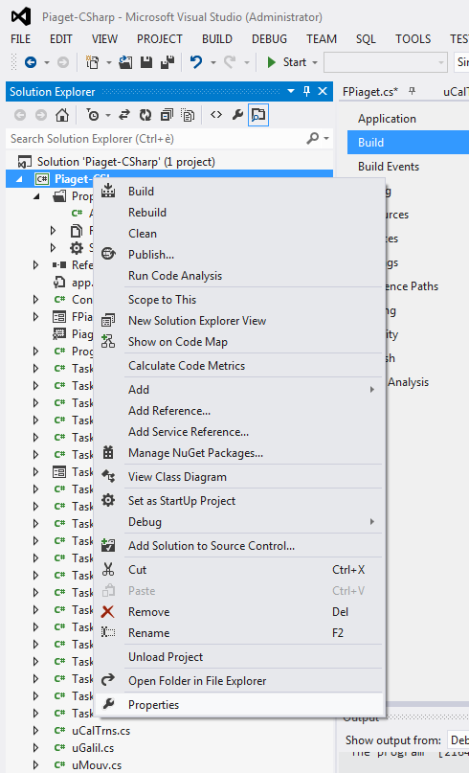
- To access to the variables of the conditonnel compilation : see the picture above
- Or press right on the project : Piaget
- Go to Properties
- Then go to Build
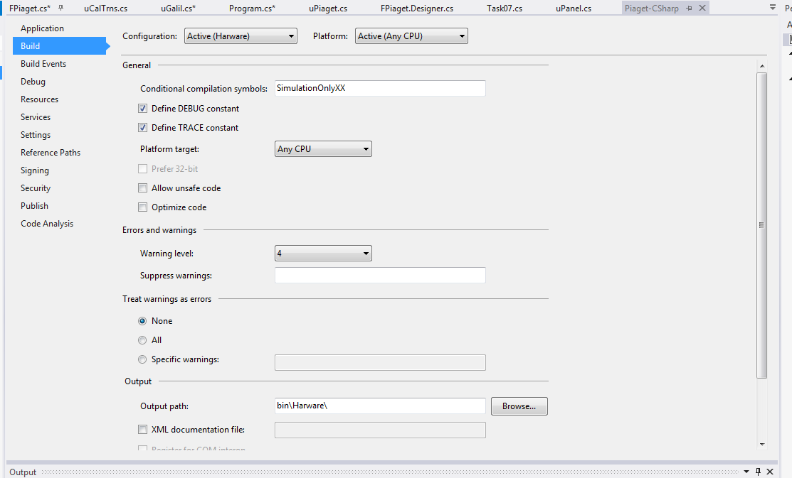
- In the space Conditionnal compilation symbols, if you write something in it, it means that condition is true
- Exemple : because the symbol is SimulationOnlyXX, the condition below is true
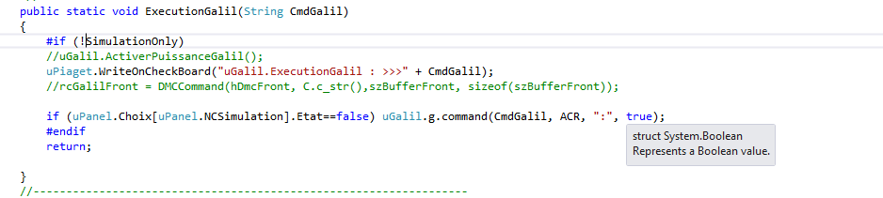
- If I want the compilator ignore the sentence, I just need to change SimulationOnlyXX onto SimulationOnly. (see below)
